Dionne F. Toombs

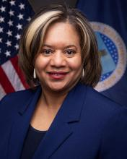
TITLE: Associate Director for Programs
Dr. Dionne Toombs is the NIFA Associate Director for Programs at National Institute of Food and Agriculture (NIFA) – U.S. Department of Agriculture’s (USDA) extramural grant funding agency for agricultural research, education, and Extension programs. In the role she provides national leadership and direction for NIFA’s science and federal assistance programs.
In 2022, she was selected to serve as the NIFA Acting Director. Previously, she was Director of the Office of the Chief Scientist (OCS), where she provided leadership on a wide range of issues affecting science programs and science policy in agricultural research, education, and economics.
With over two decades of USDA service, Dr. Toombs has served in various leadership roles, including the Division Director of Nutrition at NIFA, National Program Leader for NIFA’s Agriculture and Food Research Initiative, and Program Specialist for Food Science and Nutrition at the former USDA Cooperative State Research Education and Extension Service, now NIFA. She started at USDA as a student intern at USDA’s Agricultural Research Service.
Dr. Toombs earned her Ph.D. in Nutritional Sciences from Howard University, her Master of Science degree in Food Science from Alabama A&M University, and her Bachelor of Science degree in Biology from Bethune-Cookman University.

